**Preliminary Investigation of a Translucent Façade with Adaptive Ventilation and an IR blocking screen**

**Author: Prageeth Jayathissa**

**20 August 2018**

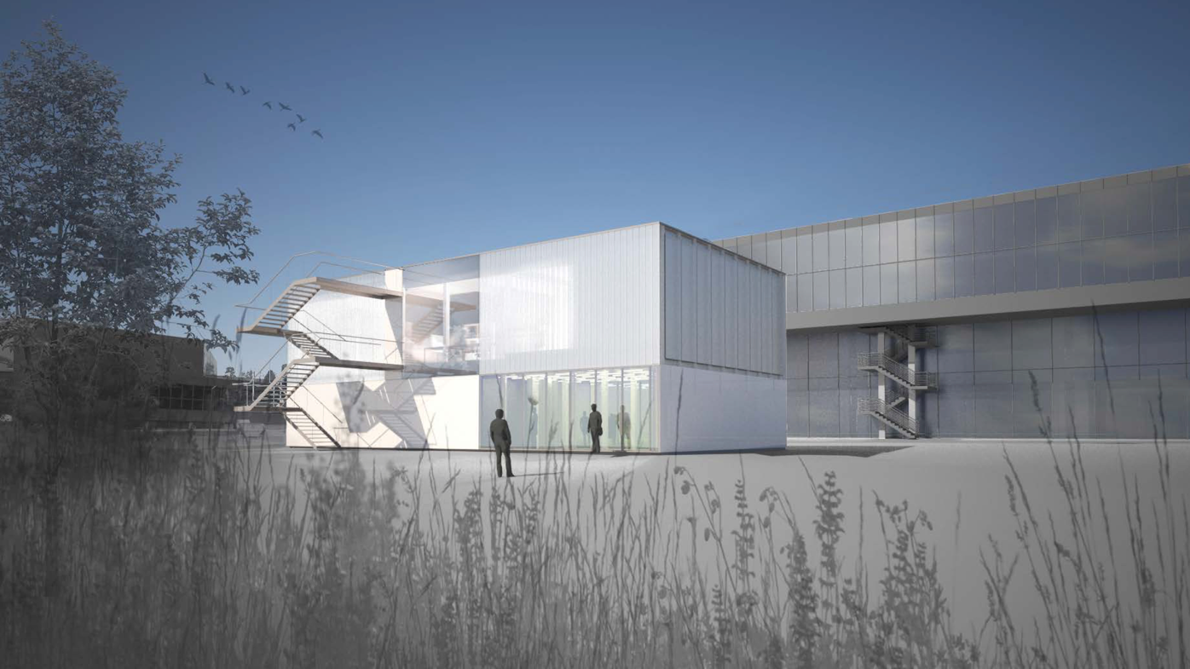

# Context

Located at the Institute for Technology in Architecture (ITA) within the ETH Department of Architecture, the A/S Chair is currently in the process of constructing the Adaptive Systems Laboratory (ASL), a testing facility capable of conducting climatic experiments on a building.

Standard energy efficient façade constructions use external shading systems to block solar gains in summer to prevent overheating, while transmitting solar radiation in winter to maintain a warm and comfortable environment with minimal use of heating.

As an alternative to external shading, a proposal was made to use an internal shading system, combined with an adaptive local ventilation to achieve the same effect.

## Construction

Figure 1 details the proposed façade construction. The outer façade construction is composed of [Wacotech Ug0.8](https://www.wacotech.de/wacotech/?page_id=37). A datasheet can be found in the appendix. This façade is composed of a Profilit Glass, with an thermal insulation filling.

The interior has an infrared blocking screen (manufacturer not yet fully defined), that can be opened or closed, thus creating an interior air cavity. The air in this cavity can be flushed out by opening two ventilators: one below the Wacotech glass frame, and one above the roof

|  |
| --- |
|  |
| Figure 1: Cross Section of Facade Construction |

## Location

The façade will be located at the following points along the facade

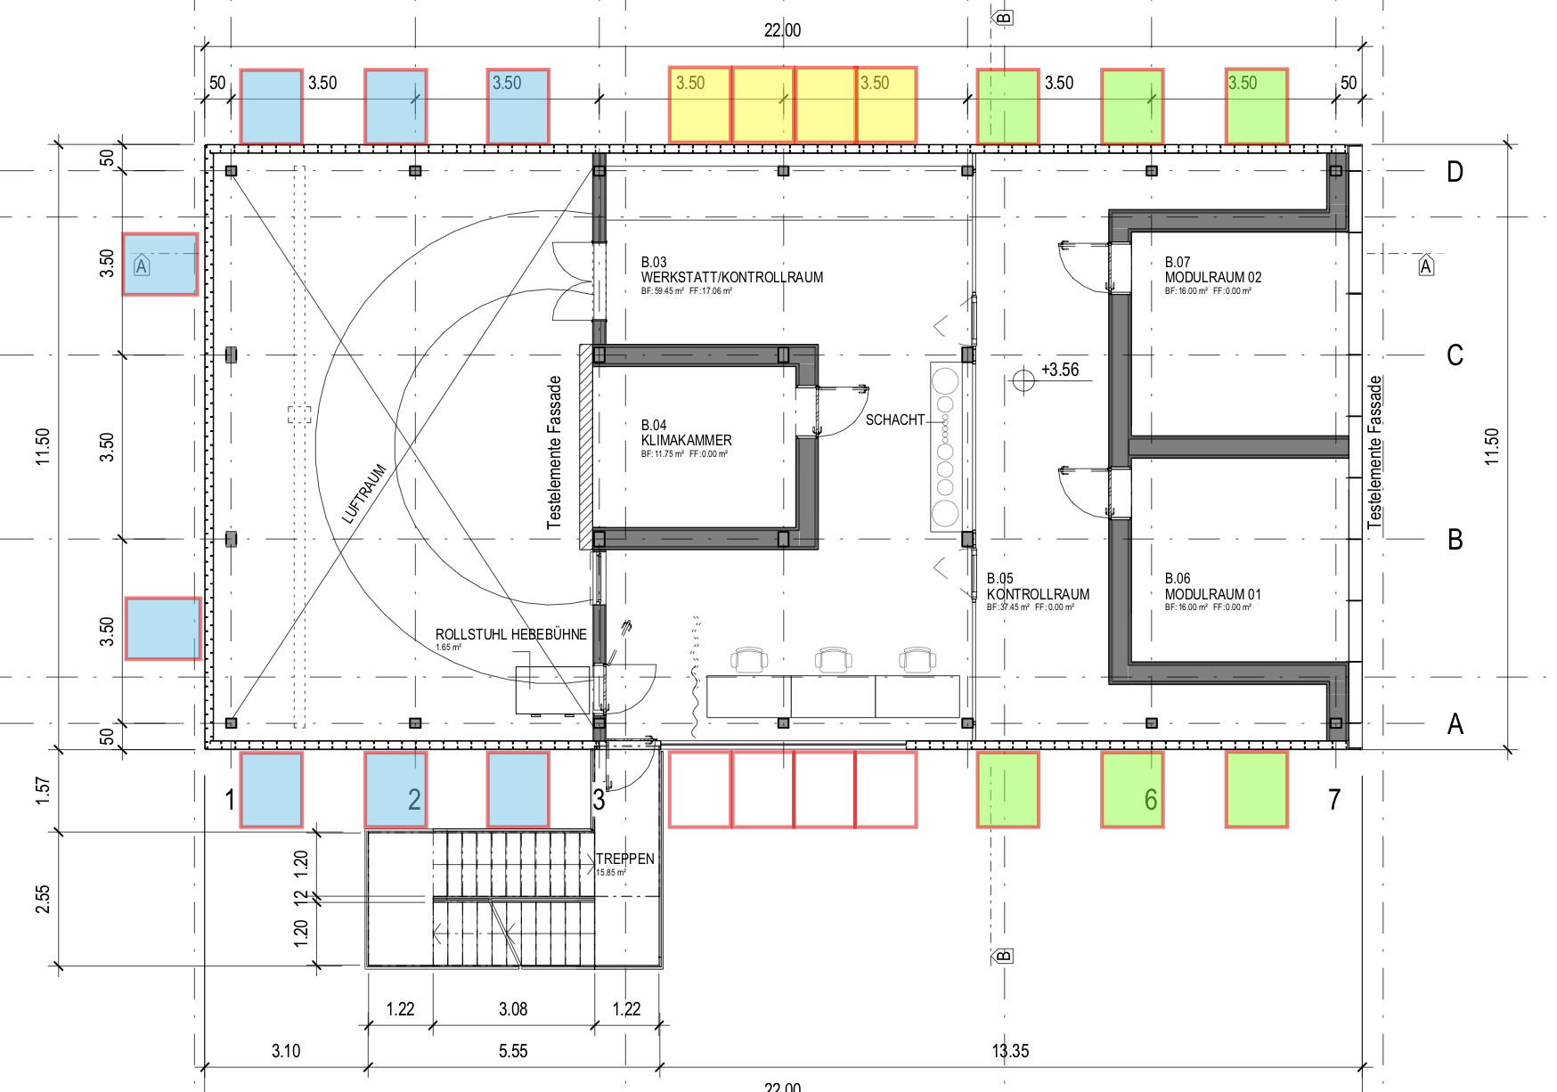

Figure 2: Proposed locations of the ventilated façade. Note that this version is old, and an update will be coming soon with less locations

# Methods of Investigation

There are three methods in which this technology can be investigated: Analyitically, Numerically, and Experimentally. In all methods we will be evaluating the system in its steady state operating conditions. That is, no transient effects such as thermal mass will be included. This may be added to the investigation at a later stage. In simple terms, we will be evaluating the system in terms of Power, and not Energy.

## Analytic investigation

The analytic investigation uses a combination of convective fluid dynamics formulas to model the air exchange, resistance modeling to model the thermal transfer through the entire construction, and a simple solar radiation assumption.

### Radiation Model

The radiation model is a very simple concept to get an idea of how the system functions. Please see the reference form the Sunreflex brochure in the appendix.

The radiation model assumes an incident radiation on the façade of 800W/m2 which would correspond to an average sunny day in Zurich.

As the façade has a g-value of 0.2: We assume that 20% (160W/m2) of this radiation is transmitted, the rest is reflected.

Of the transmitted radiation we assume that 75% of this is directly transmitted, while the other 25% is absorbed and transmitted in the form of long wave radiation. This leaves us with 40W/m2 absorbed at the glass node, and 120W/m2 transmitted

The interior blind has effectively no transmission, and an absorption of 25% of the remaining 120W/m2. This leaves us with a façade absorption of 30W/m2 and a reflection of 90W/m2.

At this point, we can continue to bounce the radiation around, but for simplicity, let’s just say that 20% of this 90W/m2 = 18W/m2 transmits through, and the other 72W/m2 gets absorbed at the glass node

 

Figure 3: Whiteboard sketch of the system

### Thermal Model

The thermodynamics can be modeled using a resistors. As shown in the figure below.

t_out: Out door temperature

q_w: Conductivity of the wacotech glass = 0.8

q_hw: Convective heat transfer between the glass and the air cavity

t_air: cavity air temperature

q_vent: equivalent ventilation heat transfer: This is dependent on the volume flow of air and its temperature

q_hf_air: Convective heat transfer between the foil and air cavity

t_f: Temperature of the foil

q_hf_in: Convective heat transfer between the foil and the inside air

Note that the absorbed radiation is included in this schematic as energy inputs: 40+72 = 112W/m2 at the glass, and 30W/m2 at the foil.

From this sketch, the necessary equations can be derived. This can be found in the same folder. WARNING: I have some mistakes in the derivation, so it would need to be re-derived as the current model results in an error. This could also be due to some assumptions, or mistakes in the methodology.



Figure 4: Resistance model of the façade construction

### Convective Model

The value of the heat transfer between the glass-aircavity, and foil-aircavity is dependent on the velocity of the naturally convecting air. The heat transfer coefficient can be calculated using [convective heat transfer phsyics](https://www.sfu.ca/~mbahrami/ENSC%20388/Notes/Natural%20Convection.pdf). This also allows us to calculate the volume of air that escapes the cavity which is required to determine q_vent



### Coded

The derived equations can be solved iteratively. I have begun coding the equations in python which can be downloaded here

<https://github.com/architecture-building-systems/convective_shading>

Please note, that due to errors in the derived equations, this software does not yet work.

### Further Simplifications

In order to simplify this further to attain first results I suggest the following simplifications:

* Assume a constant convective transfer coefficient, and constant defined air velocity. This will remove the entire convective aspect of the calculation and simplify it a lot
* Remove q_vent, and replace with a negative power loss which can be assumed based on the constant defined air velocity assumed above. By doing this you have a linear circuit which can be added together and calculated by hand without a computer

### Control

The advantage of the analytical model, is the ability to utilize it in building control as an adaptive system. This could in theory pave the path to a future PhD Thesis.

## Finite Element Analysis

The ventilated façade may also be solved using finite element analysis (FEA). Due to the Multiphysics nature of the analysis (combination of radiation, convective and conductive heat exchanges), it may be beneficial to simplify some of these components using the assumptions used in the analytical model.

The FEA has a tendency to be error prone. It is therefore heavily recommened to cross validate with either an experimental set up, or analytical model

## Experimental Set Up

Planning phase of the experimental set up is due to take place on the 29th August 2018, and due to be constructed by the end of September.

# Appendix



